The Cell – The Fundamental Unit of Life

Every living thing you have ever seen — from the blue whale swimming in the ocean to the moss growing on a rock, from the tree outside your window to your own body — is made of cells. You began as a single cell. That cell divided. Those cells specialized. And now, trillions of cells work together to keep you alive. Yet most people go through life without ever seeing a single cell or considering the principles that govern them.
Biology is not merely a subject taught in classrooms. It is the study of life itself. From the bacteria that digest food to the neurons that let you read these words, from the plant cells that produce oxygen to the immune cells that fight disease, cells govern every moment of existence. Understanding cells means understanding what life is — and how it works.
This reading material explores the history of cell discovery, the scientists who revealed the hidden world of cells, the tools used to see them, the modern cell theory, and the major differences between the two great classes of cells: prokaryotes and eukaryotes.

Part 1: What Is Cell Biology and Why Does It Matter?

Definition of Cell Biology
Cell biology is the scientific study of cells — their structure, function, and behavior. It seeks to understand the fundamental unit of all living organisms. Cell biology explains how organisms grow, how wounds heal, how diseases develop, and how life is passed from one generation to the next.

Why Cell Theory Matters in Biology
Aspect | Explanation | Examples
Understanding life | Cell theory defines what it means to be alive | All organisms are made of cells; cells  come from existing cells
Medicine | Understanding cells helps treat diseases | Cancer (uncontrolled cell division),  bacterial infections (targeting  prokaryotic cells)
Biotechnology | Cell knowledge drives innovation | Stem cell therapy, cloning, vaccine  production
Classification | Cell structure determines how life forms are grouped | Prokaryotes vs. eukaryotes; plants vs.  animals
Evolution | Cell theory explains the unity and diversity of life | All life shares a common cellular  ancestor

What Would Life Be Like Without Cell Theory?
Imagine a world where no one understood that living things are made of cells. Surgery would be guesswork. Doctors would not know that germs cause infection. Vaccines would not exist. Antibiotics would never be discovered. Even simple ideas — that a cut heals because new cells grow, that plants need sunlight to feed their cells, that you inherit traits from your parents through cells — would be unknown. Every advance in modern biology and medicine depends entirely on the understanding that all life is cellular.

Part 2: The Development of Cell Theory — A Historical Analysis
The cell theory did not appear overnight. It emerged over 200 years through the work of several scientists using increasingly sophisticated microscopes.

Key Contributors and Their Contributions
Scientist | Year | Contribution | Significance
Robert Hooke | 1665 | Used a compound microscope to examine thin slices of cork. Saw tiny, box-like compartments which he named "cells" (from Latin cella, meaning small room). | First person to use the term "cell" and first to describe cellular structures, though he observed only dead plant cell walls.
Antonie van Leeuwenhoek | 1670s–1720s | Improved lens-making techniques, creating single-lens microscopes more powerful than Hooke's. First to observe living cells: bacteria, protists, red blood cells, and sperm. Called them animalcules. | Opened the door to microbiology. Proved that living cells exist and that tiny organisms are alive.
Matthias Schleiden | 1838 | Concluded that all plants are made of cells after studying plant tissues under the microscope. | Proposed the first part of the classical cell theory: all plants are composed of cells.
Theodor Schwann | 1839 | Extended Schleiden's idea to animals. Concluded that all animals are also made of cells. | Together with Schleiden, established that all living things (plants and animals) are composed of cells — the foundation of cell theory.
Rudolf Virchow | 1855 | Studied cell division and disease. Proposed Omnis cellula e cellula — "all cells arise from existing cells." | Completed cell theory by disproving spontaneous generation (the idea that life arises from non-living matter).

How Their Work Built the Theory
The development of cell theory followed a logical progression:
- Hooke saw the containers (cell walls of dead plants).
- Leeuwenhoek saw the contents (living cells and microorganisms).
- Schleiden and Schwann made the generalization (all living things are made of cells).
- Virchow added the origin (cells come only from other cells).
Without any one of these scientists, the theory would have been incomplete.

Part 3: Tools of Discovery — Light vs. Electron Microscopes
Scientists could not have developed cell theory without microscopes. The type of microscope used determines what cell structures can be seen.

Comparison of Light Microscope and Electron Microscopes
Feature | Light Microscope (LM) | Scanning Electron Microscope (SEM) | Transmission Electron Microscope (TEM)
Type of beam | Visible light | Beam of electrons | Beam of electrons
Maximum magnification | ~1,500× | ~300,000× | ~2,000,000×
Maximum resolution | ~200 nanometers (0.2 μm) | ~1–10 nanometers | ~0.1 nanometers
Specimen condition | Living or dead | Dead (must be dried and coated with metal) | Dead (must be cut into ultra-thin slices)
Image produced | Colored (natural or stained) | Black and white (3D surface image) | Black and white (2D internal image)
What you see | Whole cells, nucleus, chloroplasts, mitochondria (as small dots) | Detailed 3D surface texture of cells and structures | Detailed internal structure of organelles (e.g., cristae in mitochondria)
Advantages | Can observe living cells; simple to use; relatively cheap; natural colors possible | Amazing 3D surface detail; very high magnification | Highest resolution possible; reveals internal organelle structure
Disadvantages | Low resolution; cannot see most organelles in detail | Cannot view living cells; expensive; complex sample preparation | Cannot view living cells; extremely expensive; requires skilled operator

Advantages Summary
- Light microscope advantage: You can watch living cells move, divide, and respond to their environment. No other tool allows this.
- Electron microscope advantage: You can see details 1,000 times smaller than light microscopes can resolve — including viruses, ribosomes, and the internal membranes of mitochondria.
Example: A mitochondrion appears as a tiny dot under a light microscope. Under a TEM, you can see its folded inner membrane (cristae), where energy production actually happens.

Part 4: The Modern Cell Theory — Four Main Parts
The classical cell theory (Schleiden, Schwann, Virchow) has been updated with modern discoveries. The modern cell theory consists of four main statements:
Part | Statement | Explanation
1 | All living organisms are composed of one or more cells. | Life exists as single-celled organisms (bacteria,  amoebas) or multicellular organisms (plants, animals,  fungi).
2 | The cell is the basic structural and functional unit of life. | The smallest structure that performs all life functions (metabolism, growth, reproduction, response to  stimuli) is the cell. Organelles alone cannot live independently.
3 | All cells arise only from pre-existing cells. | Life does not spontaneously appear from non-living  matter. Cells divide to produce new cells (mitosis in eukaryotes, binary fission in prokaryotes).
4 | Cells contain hereditary information (DNA) that is passed from cell to cell during division. | Modern addition: DNA in the nucleus (or nucleoid  region) directs the cell's activities and is copied and transmitted to daughter cells.

Why These Four Parts Matter Together
- Parts 1 & 2 establish what life IS (cellular organization).
- Part 3 establishes where life COMES FROM (other cells).
- Part 4 establishes HOW life CONTINUES (heredity).
Without any one part, our understanding of life would be incomplete.

Part 5: Prokaryotic vs. Eukaryotic Cells — Diversity and Classification
One of the most important ways biologists classify life forms is by cell type. All cells fall into two major categories: prokaryotic and eukaryotic.

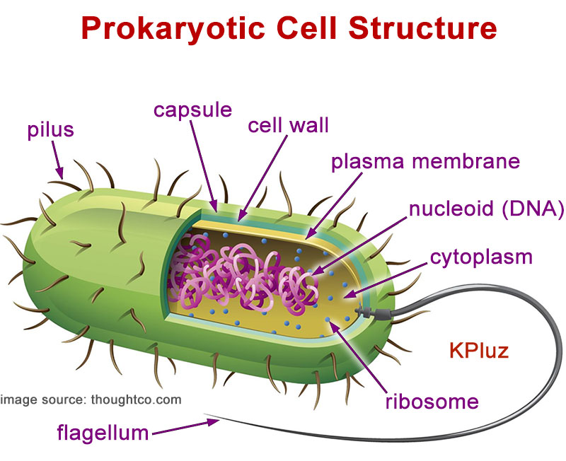

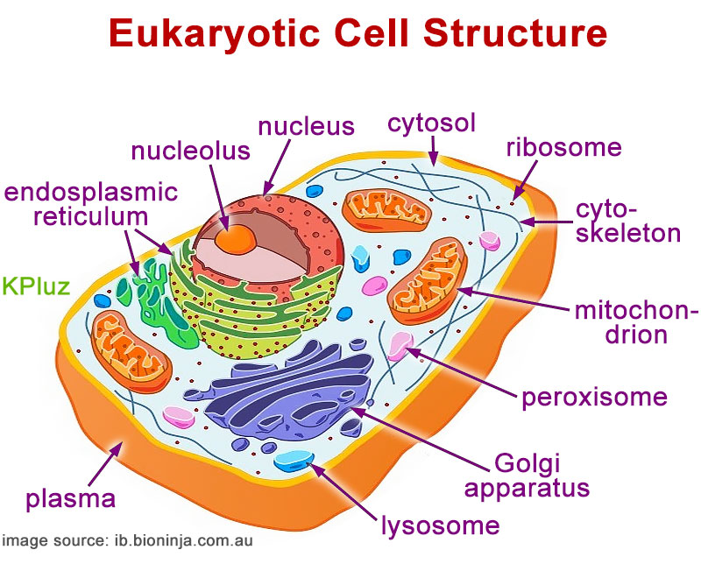

Comparison Table: Prokaryotic vs. Eukaryotic Cells
Feature | Prokaryotic Cells | Eukaryotic Cells
Size | ~1–5 μm (small) | ~10–100 μm (10–100× larger)
Nucleus | No true nucleus (nucleoid region only) | True nucleus with nuclear  envelope
Membrane-bound organelles | Absent | Present (mitochondria, ER, Golgi, lysosomes, etc.)
DNA structure | Circular DNA, single chromosome | Linear DNA, multiple  chromosomes
Ribosomes | Smaller (70S) | Larger (80S)
Cell division | Binary fission (simple division) | Mitosis or meiosis  (complex division)
Examples | Bacteria, Archaea | Animals, plants, fungi, protists
Typical complexity | Unicellular only | Unicellular or multicellular

Significance in Diversity and Classification of Life Forms
The presence or absence of a nucleus is the highest-level classification category in biology.
- Domain Bacteria → Prokaryotic
- Domain Archaea → Prokaryotic (different biochemistry, but also no nucleus)
- Domain Eukarya → Eukaryotic (includes Kingdom Animalia, Plantae, Fungi, Protista)

Why This Distinction Matters
- Evolutionary significance: Prokaryotes appeared ~3.5 billion years ago; eukaryotes appeared ~1.5–2 billion years ago. Eukaryotes evolved from prokaryotic ancestors (endosymbiotic theory — mitochondria and chloroplasts were once free-living bacteria).
- Ecological significance: Prokaryotes dominate Earth's biomass and drive global nutrient cycles (nitrogen fixation, decomposition). Eukaryotes include most visible life (plants, animals, fungi).
- Medical significance: Many antibiotics target prokaryotic structures (e.g., ribosomes or cell walls) without harming human eukaryotic cells. This is why you can take penicillin for a bacterial infection — it attacks bacterial cell walls, which human cells do not have.
- Classification significance: If you find a new organism and look at it under a microscope, the FIRST question is: Does it have a nucleus? The answer places it in either Domain Bacteria/Archaea or Domain Eukarya.

Key Terms
Term | Definition
Cell | The basic structural and functional unit of all living organisms
Cell theory | The unifying biological principle that all organisms are made of cells,  the cell is the basic unit of life, and cells arise from existing cells
Prokaryotic cell | A cell lacking a nucleus and membrane-bound organelles; DNA is in a  nucleoid region
Eukaryotic cell | A cell containing a true nucleus and membrane-bound organelles
Nucleus | Membrane-bound organelle that contains the cell's DNA in eukaryotic  cells
Organelle | A specialized subunit within a eukaryotic cell that performs a specific  function
Nucleoid | The region in a prokaryotic cell where circular DNA is located (no  membrane)
Light microscope | Uses visible light to magnify specimens; can view living cells
Electron microscope | Uses beams of electrons to magnify specimens; much higher resolution  but cannot view living cells
Resolution | The ability to distinguish two close objects as separate
Magnification | The ratio of an object's image size to its actual size

Review Questions
Responses should be written on a separate sheet of paper.
- Describe the specific contribution of each of the following scientists to the development of cell theory: Robert Hooke, Antonie van Leeuwenhoek, Matthias Schleiden, and Rudolf Virchow. Explain how their work built upon previous discoveries.
- A biologist wants to observe how a living white blood cell moves and engulfs a bacterium. Which type of microscope should she use — light microscope or electron microscope? Explain your reasoning using the advantages and disadvantages of each type.
- State the four main parts of the modern cell theory in complete sentences.
- Draw a scaled diagram of a prokaryotic cell and a eukaryotic cell side by side. Your drawings must clearly show:
  - The relative size difference (label approximate sizes in micrometers)
  - The presence or absence of a nucleus
  - At least three organelles found only in eukaryotic cells
- Explain why the distinction between prokaryotic and eukaryotic cells is significant for:
  - Classification of life forms (how scientists group organisms)
  - Medicine (why antibiotics can kill bacteria without harming human cells)
- A new single-celled organism is discovered in a hot spring. Under an electron microscope, scientists observe that it has a nucleus, mitochondria, and small ribosomes. Is this organism prokaryotic or eukaryotic? To which domain does it belong? Provide evidence from the lesson to support your answer.

